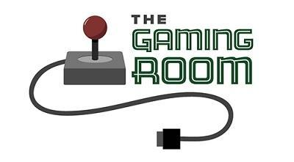

Draw It or Lose It

CS 230 Project Software Design Template
Version 1.0

Table of Contents

CS 230 Project Software Design Template 1
Table of Contents 2
Document Revision History 2
Executive Summary 3
Design Constraints 3
System Architecture View 3
Domain Model 3
Evaluation 3
Recommendations 5

Document Revision History

Version | Date | Author | Comments
1.0 | 03/18/26 | Kevin Peters | Initial release

Instructions
Fill in all bracketed information on page one (the cover page), in the Document Revision History table, and below each header. Under each header, remove the bracketed prompt and write your own paragraph response covering the indicated information.

Executive Summary

Creative Technology Solutions (CTS) has been asked to redefine the existing game, "Draw It or Lose It." Originally developed for Android, the goal is to enable cross-play by transitioning to a web-based Java application while maintaining the original mechanics. To ensure system integrity, a Singleton Pattern has been implemented. This ensures that only one instance of the GameService exists in memory, preventing data conflicts and potential corruption.

Design Constraints

Transitioning from a local Android app to a web-enabled game changes how users interact with the system. We must now support multiple concurrent users accessing a centralized server. Because the client requires a single-instance coordinator for game logic, the server must be capable of tracking every game, team, and player instance globally, rather than relying on the user's device to manage local state.

System Architecture View

Please note: There is nothing required here for these projects, but this section serves as a reminder that describing the system and subsystem architecture present in the application, including physical components or tiers, may be required for other projects. A logical topology of the communication and storage aspects is also necessary to understand the overall architecture and should be provided.

Domain Model

The app is made of a main class that is used to start the making of the game. This includes the teams and players. This is done through the GameService class which uses a Singleton Pattern to make sure only one GameService class exists at a time. This is done with the GameService checking if there is already a running instance. It only creates a new instance if one is not found in memory. This creates a single point of control for the entire game environment.
The game creates a type of control using inheritance. The class Entity controls the attributes of id and name. Using Game, Team, and Player classes all deriving from Entity, the software is now set up to be reused as every object holds a consistent identity structure.
The client also requested unique names. This is accomplished by the GameService using the Iterator Pattern. Essentially, GameService does the same thing as with the Singleton Pattern, just instead of checking for its own existence, it checks for existing names in the list of games. If an identical name is found, it does not allow the new one to be created.

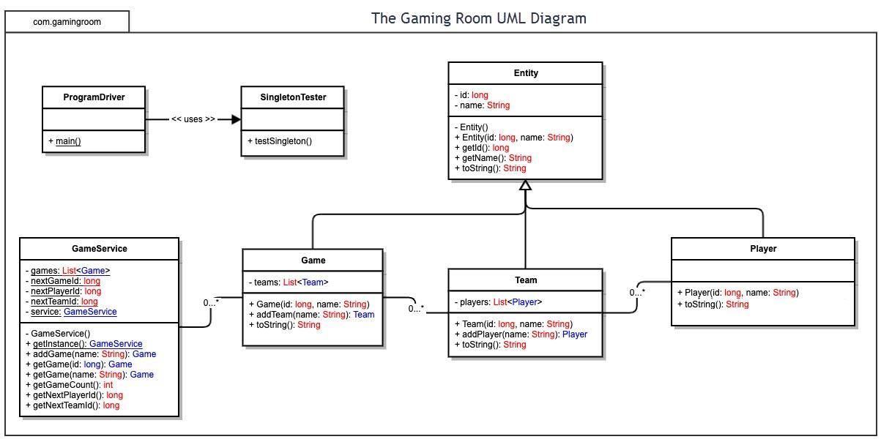

Evaluation

Using your experience to evaluate the characteristics, advantages, and weaknesses of each operating platform (Linux, Mac, and Windows) as well as mobile devices, consider the requirements outlined below and articulate your findings for each. As you complete the table, keep in mind your client’s requirements and look at the situation holistically, as it all has to work together.

In each cell, remove the bracketed prompt and write your own paragraph response covering the indicated information.

Development Requirements | Mac | Linux | Windows | Mobile Devices
Server Side | <Evaluate Mac for its characteristics, advantages, and weaknesses for hosting a web-based software application.> | <Evaluate Linux for its characteristics, advantages, and weaknesses for hosting a web-based software application.> | <Evaluate Windows for its characteristics, advantages, and weaknesses for hosting a web-based software application.> | <Evaluate Mobile Devices for their characteristics, advantages, and weaknesses for hosting a web-based software application.>
Client Side | <Determine the software development considerations (cost, time, expertise) that are necessary for supporting multiple types of clients as they pertain to Mac.> | <Determine the software development considerations (cost, time, expertise) that are necessary for supporting multiple types of clients as they pertain to Linux.> | <Determine the software development considerations (cost, time, expertise) that are necessary for supporting multiple types of clients as they pertain to Windows.> | <Determine the software development considerations (cost, time, expertise) that are necessary for supporting multiple types of clients as they pertain to Mobile Devices.>
Development Tools | <Identify the relevant programming languages and tools (IDEs and other tools) that are used to build this type of software for deploying on Mac.> | <Identify the relevant programming languages and tools (IDEs and other tools) that are used to build this type of software for deploying on Linux.> | <Identify the relevant programming languages and tools (IDEs and other tools) that are used to build this type of software for deploying on Windows.> | <Identify the relevant programming languages and tools (IDEs and other tools) that are used to build this type of software for deploying on Mobile Devices.>

Recommendations

Analyze the characteristics of and techniques specific to various systems architectures and make a recommendation to The Gaming Room. Specifically, address the following:

- Operating Platform: <Recommend an appropriate operating platform that will allow The Gaming Room to expand Draw It or Lose It to other computing environments.>

- Operating Systems Architectures: <Describe the details of the chosen operating platform architectures.>

- Storage Management: <Identify an appropriate storage management system to be used with the recommended operating platform.>

- Memory Management: <Explain how the recommended operating platform uses memory management techniques for the Draw It or Lose It software.>

- Distributed Systems and Networks: <Knowing that the client would like Draw It or Lose It to communicate between various platforms, explain how this may be accomplished with distributed software and the network that connects the devices. Consider the dependencies between the components within the distributed systems and networks (connectivity, outages, and so on).>

- Security: <Security is a must-have for the client. Explain how to protect user information on and between various platforms. Consider the user protection and security capabilities of the recommended operating platform.>

